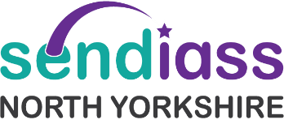

**SENDIASS North Yorkshire**

**Our agreement & expectations 2024/25**

**Sendiass North Yorkshire will provide the relevant information and advice to everyone using our service. We aim to empower parents, carers, young people and professionals to gain a understanding of SEND policies, process and relevant Law and how it applies to their situation.**

**What you can expect from us:**

* We will be confidential, impartial, arm’s length from the Local Authority and provide information, advice, and support to achieve the best outcomes possible.
* We will be honest, reliable, non-judgmental, all trained or working towards IPSEA Level 3 in SEND law.
* We will gather information during your contact and record brief notes on our confidential database so should you return, you do not have to re tell all your situation.
* The SENDIASS coordinator will offer information and advice by phone, emails, and virtual meetings.

**You can help us by:**

* Working together to agree next steps.
* Keeping us updated about relevant changes because we are not informed by other services.
* Please do not add us into emails unless relevant to our role as it takes time that we need to support many families.
* Giving us plenty of notice for any meetings (at least 10 working days) so we can support you in preparing.
* Leaving us a message if you phone.
* Letting us know when your issue has been resolved, we like to hear good news.
* By filling in our evaluation form as it really helps us to learn and develop our service.

**Please note.**

**If we do not hear from you within one month, then we will assume you no longer need our support and shall inform you by email that we shall close our contact. You will be welcome to return to our advice line with any new concerns.**